**HCA YouTube Channel**

**Introduction:**

This intranet youtube channel for HCAHEALTHCARE has been developed using ReactJs front end application.

The code was deployed into githup pages for testing purpose.

Please find the below deployed url in git.

<https://selvaraj1986.github.io/ReactApp/>

user can able to see only the “HCAHEALTHCATE” channel videos.

by default, the pages will display the "COVID-19 Vaccine Podcast” videos always showing fist in the list.

User can be able to search the videos what they want to see.

By default screen with "COVID-19 Vaccine Podcast”

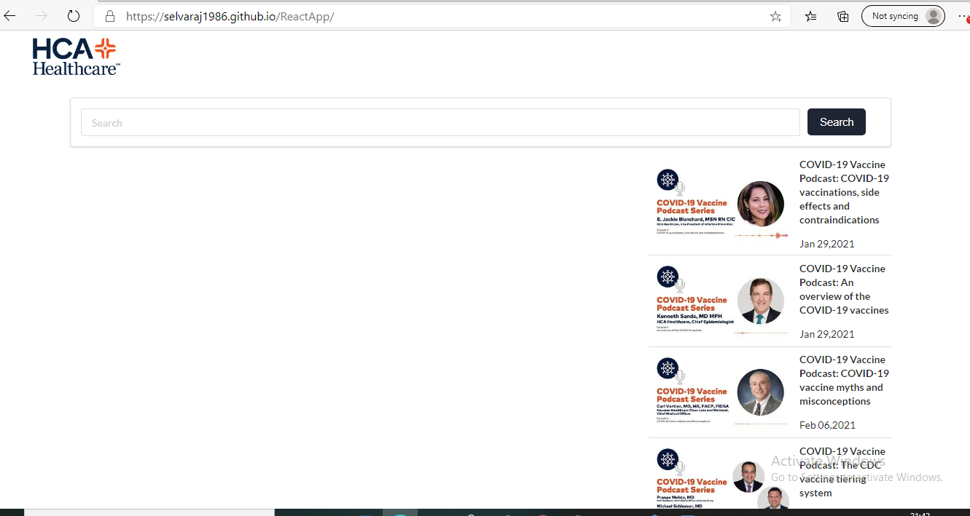

By search the videos

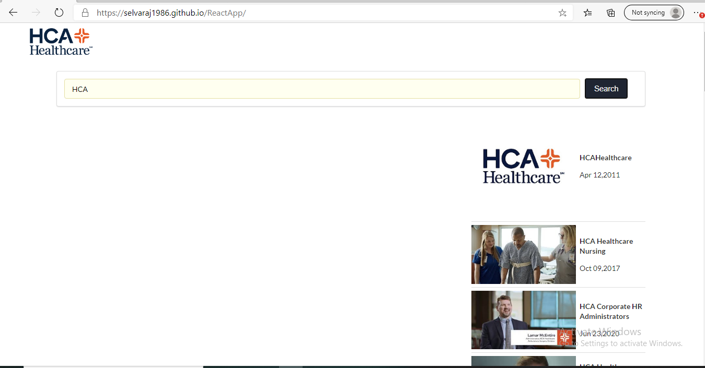

To see the specific video



